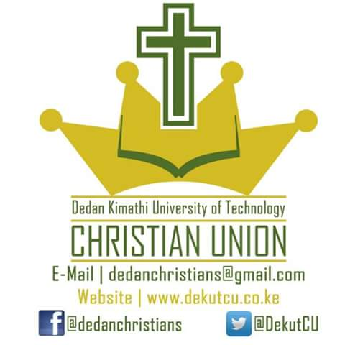

**DEDAN KIMATHI UNIVERSITY OF TECHNOLOGY CHRISTIAN UNION END OF MAY – AUGUST SEMESTER MISSIONS.**

**(ORGANIZATION OF THE MISSION AND THE FINANCIAL COST OF THE MISSIONS.)**

**Introduction.**

For this season, May to august of 2018, that is the last semester of the 2017/2018 spiritual year, we shall be having two end of semester missions.

We will split the missioners in to two, one group going to Isiolo and another to Murang’a. this will allow for easy aminstration of the missions, since the groups are smaller, and also this will give more opportunities for the CU members to grow in ministering and in leadership.

**Organization.**

*Isiolo Mission.*

The Isiolo mission will be in Bula Pesa, specifically in Bula. We will be working with Life Ministry, a Christian Organization which conducts frontier missions, trainings for leadership and missionary work etc. Life Ministry will link us to the ground, were they give us contact to the Pastor on the ground, and provide accommodation for us. Apart from this also the Life Ministry will have some sessions to train the missioneries on reaching out to muslims.

The program of this mission will be quite different from what we have gotten used to, in that we won’t have open air meetings.

Bula is Islam dominated, with 99% muslims. We thank God for His doing, and His great love and power which He will show in this place even as we will see people with muslim background receiving Christ as their Personal Lord and Saviour.

*Murang’a Mission.*

The Murang’a Mission will be happening in Kangema, and we’ll be working with Soul Harvestors Church. This mission will be requiring 35 missioners.

The program of this mission will be similar to most of the other missions we have been having, that is, we’ll have morning prayers in the morning, the door to door and open air meeting, and revival meetings.

Written by:

Milton Mulwa,

DeKUT CU Missions’ Coordinator.